**User Guide**

This manual is meant to provide a quick guide to the app's key functions. The app's features include the ability to manage contacts, including adding, editing, and removing contacts.

**To Create a Contact**

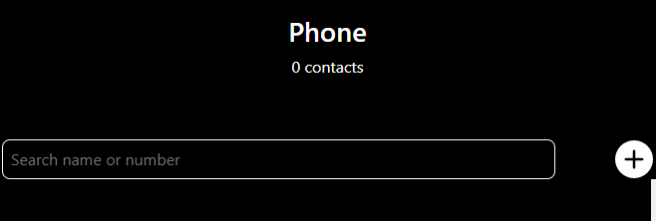

Step 1: Click the button

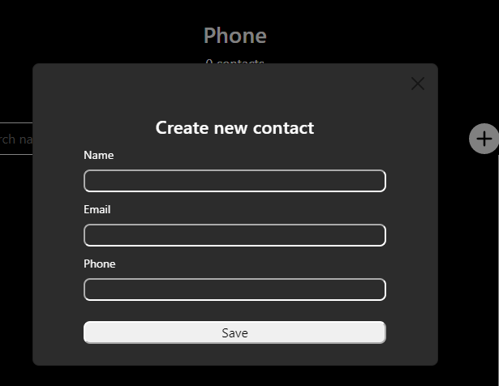

Step 2: Insert the Name, phone number and email then click the save button to save the contact.

**To Update a Contact**

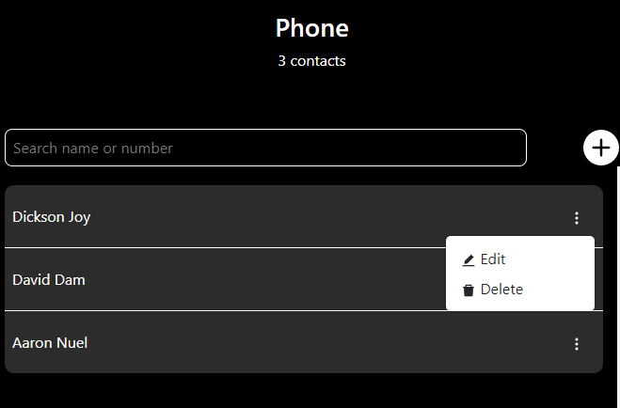

Step 1: Click on the kebab menu in front of the contact you want to edit, then click edit

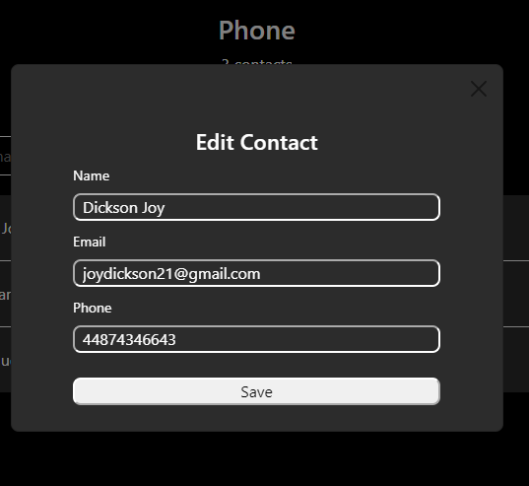

Step 2: Edit any information you want on the contact and click the save button to save.

**To Delete:** Click the kebab button in front of the contact you want to delete, then click delete.



**To Search and Filter**

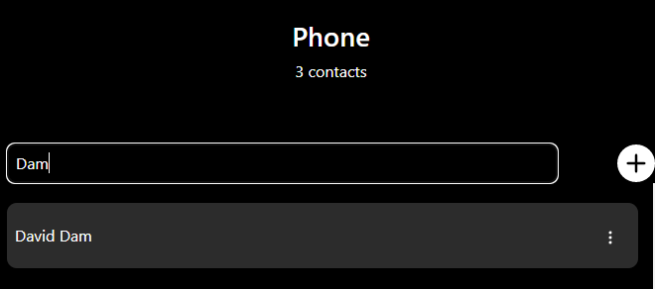

Click the search bar and type either a name or phone number of the contact to filter.